**AIM:**

To verifythe maximum power transfer theorem and verify the same theoretically.

**APPARATUS:**

100–ohm resistors, ammeter (0-mA), voltmeter (0-V) , regulated power supply (0-30V)

**CIRCUIT DIAGRAM**:-

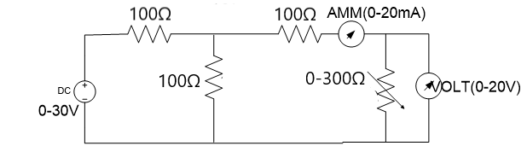

**Theory :**

**It states that ‘the maximum power is delivered from a source to a load when the load resistance is equal to the source resistance.’**

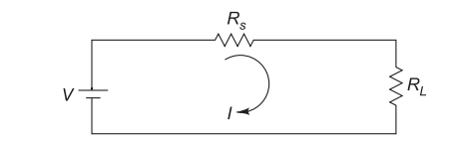

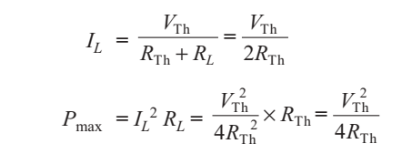

A resistive load will be consumptive maximum power from the supply when the load resistor is equal to the equivalent (Thevenin) network resistor".

**PROCEDURE :**

* 1. Adjust the supply voltage to 20V.
  2. Vary the load resistance(RL) using the slider given in the circuit.
  3. Click on *Simulate* to get value of current and voltage .
  4. Click on *Add To Table* for observation table entry.
  5. Repeat the steps 2,3 and 4.
  6. After taking your final reading Click on *Plot Graph*.
  7. The graph will be plotted.

**OBSERVATION AND CALCULATIONS**:-

| S.No. | V (volts) | I (amps) | P=VxI (watts) | RL=V/I (Ω) |
| --- | --- | --- | --- | --- |
|  |  |  |  |  |
|  |  |  |  |  |
|  |  |  |  |  |
|  |  |  |  |  |

**RESULT :**

1. We have successfully plotted the graph of RL VS P.

**Pre Questions**

**1) If two equal resistances of 12 ohm are connected in parallel find out the equivalent resistance**

**A .0.1667ohm**

**B.6 ohm**

**C. 3 ohm**

**D 12 ohm**

**2) In a dc circuit independent current source is 4 ampere and parallel resistance is 2 ohm, convert into a voltage source and series resistance the values are**

**A.8 V, 2 ohm**

**B. 2V,2 ohm**

**C.4 V,2 ohm**

**D. 2V ,4 ohm**

**3)------------- states that algebraic sum of all the voltages in any closed loop is zero**

**A. Kirchhoff’s Voltage Law**

**B. Kirchhoff’s Current Law**

**C. Ohm’s law**

**D. None of above**

**post Questions**

**1. For maximum power transfer theorem, the relation between load resistance RL and internal resistance of voltage source RS is_____**

**a. RL =2RS**

**b. RL=RS**

**c. RL =1.5RS**

**d. RL =0.5RS**

**2. If the value of Thevenin’s equivalent voltage is 20v and thevenin’s resistance is 10 ohm, find maximum power delivered.**

**a) 10 W**

**b) 20w**

**c) 15w**

**d) 30w**